|  |  |
| --- | --- |
| **Project Case** |  |
| COMP6232001 | COMP6800 | COMP6800001  Human and Computer Interaction |
| **Computer Science** | **E232-COMP6800-FT03-00** |
| ***Valid on*** *Even Semester Year 2022/2023* | **Revision 00** |

1. Kelompok tidak diperkenankan untuk:

*Members of the group are prohibited from:*

* + - Melihat sebagian atau seluruh jawaban kelompok lain,

*Seeing a part or the whole answer from other groups,*

* + - Menyadur sebagian atau seluruh jawaban dari buku, catatan, video, dan jenis referensi lainnya,

*Retell a part or the whole answer from books, notes, videos, and other references,*

* + - Menyadur sebagian atau seluruh jawaban dari internet,

*Retell a part or the whole answer from the internet,*

* + - Mengumpulkan jawaban yang tidak sesuai dengan tema soal,

*Submitting an answer with a different theme from the given case,*

* + - Melakukan tindakan yang menyebabkan jawaban dicontek oleh orang lain atau kelompok lain, baik disengaja maupun tidak disengaja,

*Doing action that could result the answer being copied by someone or other groups, intentionally or unintentionally,*

* + - Melakukan tindakan kecurangan lainnya.

*Committing other dishonest actions.*

1. Jika kelompok terbukti melakukan tindakan seperti yang dicantumkan pada butir ke-1, maka nilai mahasiswa dan/atau kelompok yang melakukan kecurangan, baik menyontek atau dicontek, akan dinolkan sesuai dengan peraturan yang berlaku.

*If it has been proven that a group has committed dishonest actions outlined in point 1 above, the whole groups related to the incident, regardless of which one copies or has their answer copied, will be issued a score of zero according to the regulation.*

1. Jawaban yang dapat diterima dan dinilai adalah jawaban yang dikumpulkan sebelum batas waktu yang telah ditentukan.

*The answer must be submitted before the designated deadline to be accepted and graded,*

1. Jawaban akan dinilai berdasarkan teknik atau metode yang diajarkan pada kelas praktikum dengan menggunakan software yang sudah ditentukan.

*The scoring will be based on the materials taught during the practicum classes using the designated software. Using different software than requested may result in your answer not being graded.*

1. Jika Anda tidak membaca peraturan ini, maka Anda dianggap sudah membaca dan menyetujuinya.

*By taking this exam, you agree to these regulations, regardless of whether you have read it or not.*

1. Persentase penilaian untuk matakuliah ini adalah sebagai berikut:

*The score will be distributed as follows:*

|  |  |  |
| --- | --- | --- |
| **Tugas Mandiri**  *Assignment* | **Proyek**  *Project* | **UAP**  *Final Exam* |
| - | 100% | - |

1. Perangkat lunak yang digunakan pada matakuliah ini adalah sebagai berikut:

*This course uses the following software:*

|  |
| --- |
| **Software**  *Software* |
| Chrome / Firefox / Microsoft Edge  Figma  Visual Studio Code |

1. Ekstensi file yang harus dikumpulkan untuk matakuliah ini adalah sebagai berikut:

*Your answers must be in the following file extensions:*

|  |  |  |
| --- | --- | --- |
| **Tugas Mandiri**  *Assignment* | **Proyek**  *Project* | **UAP**  *Final Exam* |
| - | FIG, HTML, CSS, JS, Image Files (JPG / PNG) | - |

1. File yang harus dikumpulkan adalah keseluruhan jawaban beserta dengan aset yang digunakan (gambar, audio, video, dll) dan dokumentasi proyek yang berisikan link referensi aset dan penjelasan mengenai aplikasi yang dibuat (terlampir bersama dengan soal).

*Include other files that can support your project, such as: all files in your project, other files (image, audio, video, etc.) used in your project, *.doc file (documentation of your project) that contains all pages in your project, reference links of additional files (image, audio, video, etc.) used in your project, the description about how to use your application, etc.*

## Soal

*Case*

**sea of FTars**

**Sea of FTars** is a classic-inspired turn-based RPG that has lots of unique hero combinations and a very interesting storyline. It tells the story of two children of the Solstice who will combine the power of the sun and moon to perform Eclipse Magic which aims to defeat the evil alchemist known as the Fleshmancer.

**efteStudio** as the publisher and developer of the game **sea of FTars** is currently planning to create a website so that people can find out more details about the game **sea of FTars** as well as get the latest updates from the game **sea of FTars**. First, **efteStudio** needs to create a **website prototype** and a **company website** that represents a picture of the **sea of FTars games**. With this website, **efteStudio** hopes to increase the number of players for the game **sea of FTars** and introduce the game to all levels of society, especially gamers. **efteStudio** as the publisher and developer of the game **sea of FTars** entrusts you as a web designer to design their **website** **prototype** and create a **company website**.

The **requirements** from **sea of FTars** are described below:

* + - 1. **efteStudio** as the publisher and developer of the game **sea of FTars** wants you to design the **website prototype** of all **five pages** before making the HTML files. The website prototype will be created using **Figma**. Ensure the website prototype that you created is the **exact same** as the website that you will make later. Each pagewill contain **header**, **navigation**, **content,** and **footer** as its structure. Consider the **color**, **layout**, and **consistency** when designing the prototype.
      2. **efteStudio** as the publisher and developer of the game **sea of FTars** wants you to build the **website attractive**, **appealing**, **fully functional**, and make sure the website is **responsive**. The website should be accessible using a mobile phone in a perfect way. To achieve that, use **5 kinds of CSS property** and **JavaScript**. Use **meta** **viewport** **tag** and **media** **screen** **rule** that will be applied if the screen is **below** **768px** screen width.
      3. The website consists of **five main pages**. They are **Home Page**, **Characters Page, Character Detail Page,** **Fan Art Page**, and **Account Page**. Below are the **requirements** for each page:
  1. **Home Page**

This page contains a **trailer** of the game sea of FTars, the **features** offered by the game, and a **place** where users can play the game.

* 1. **Characters Page**

This page contains a **list of the characters** in the sea of FTars game. You must display the **name** and **image of the character** and you must **separate** the existing characters **into 2 parts**, namely **hero** and **enemy**.

* 1. **Character Detail Page**

On this page you must display the **name** of the character, the **picture** of the character, the **animation** of the character and you must give the **story** of the character

* 1. **Fan Art Page**

This page contains posts submitted by fans of the game sea of FTars. Each post has its own information, such as the post **title**, **sender's name**, **image**, and the **date** the post was made.

* 1. **Account Page**

This page is used to register a new account. The user needs to submit some **personal information**, such as **username**, **country**, **email**, **password**, and **user must agree with terms and conditions**.You are asked to create **five kinds of form components** and **five kinds of validation**. For validation, you must create it using **JavaScript** and **don’t use regular expression**.

Answer:

Link Figma:

<https://www.figma.com/file/9IYFMNhBTGXmQD8pNvsa1B/Sea-Of-Ftars?type=design&node-id=0%3A1&t=ti5lG43qJINPwvd2-1>

**1.Navigation Bar**

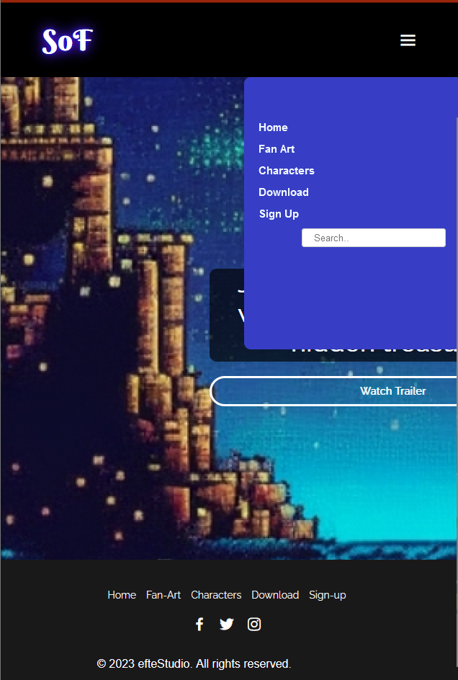

Disini, saya menggunakan interactive and responsive navigation bar, dimana kalau digunakan di layer kecil akan muncul hamburger menu, dan jika kita pencet/click akan muncul navigation bar nya yaitu Home, Fan Art, Characters, Dowmload, dan juga sign up, dan jika kita pencet/click hamburger menu nya lagi, navigation bar akan tutup.

**2.Footer**



Untuk footer, saya masukkan list dari navigation bar yang jika di pencet akan menuju ke halaman tersebut, saya juga memasukkan sosial media twitter, facebook, dan juga Instagram, dan terakhir saya memasukkan efteStudio sebagai publisher and developer dalam footer.

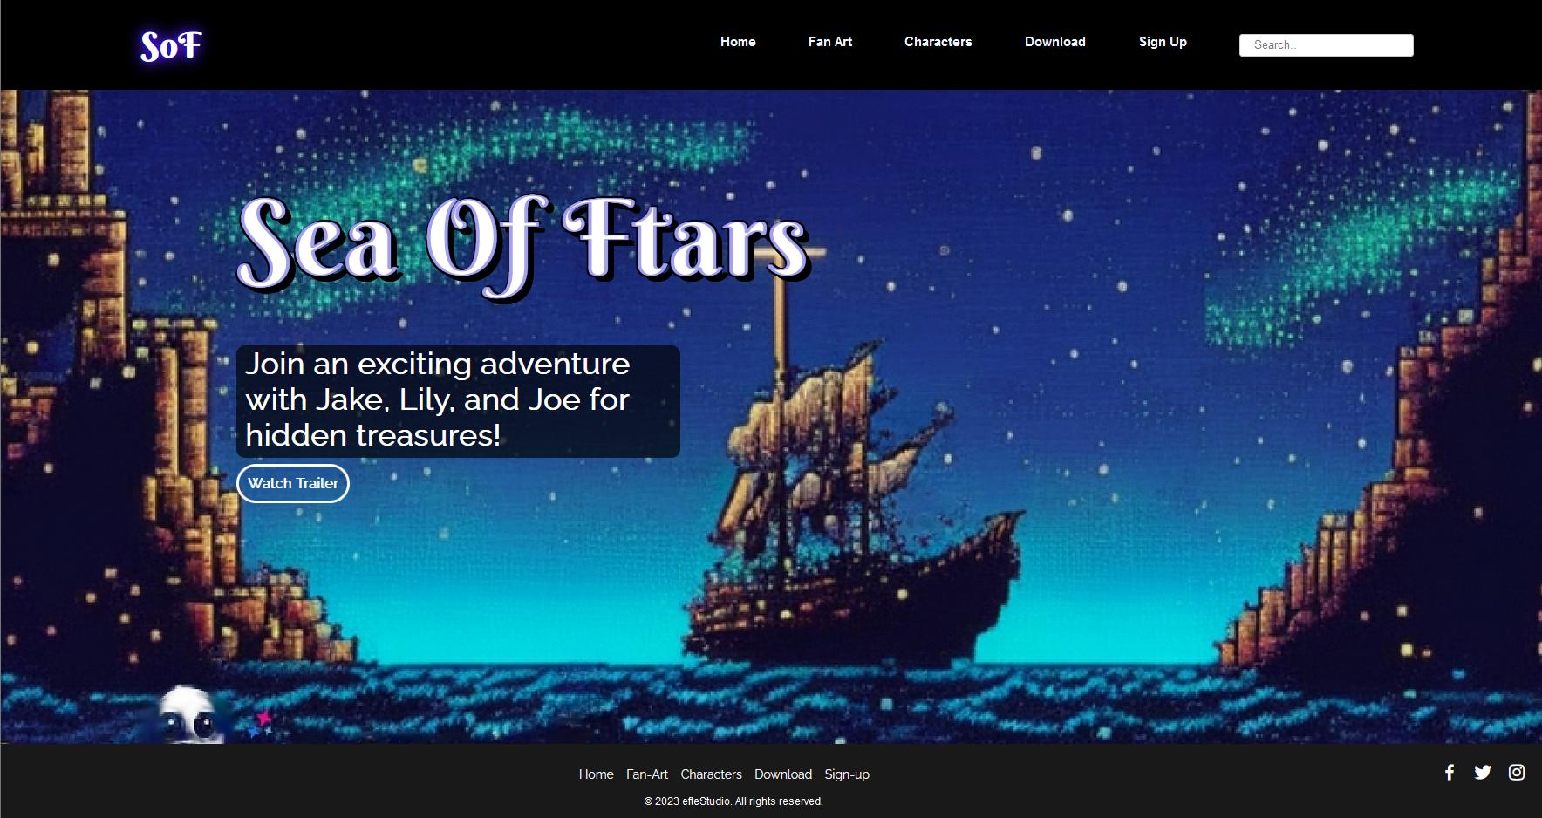**3.Halaman Beranda**

Untuk Halaman beranda, saya memasukkan logo dari Sea Of stars menggunakan font yang saya ambil dari google font yaitu Berkshire wash, font text persuasifnya raleway, dan saya modifikasi sedemikian rupa. Lalu saya memasukkan button “Watch Trailer” yang menuju ke trailer video youtube game asli sea of stars. Saya juga memasukkan background gambar laut dengan bintang di langit, guna mencocokkan judul.

Referensi:

Link video trailer youtube: <https://www.youtube.com/watch?v=BMComOd9qP4>

Link font Berkshire wash: <https://fonts.google.com/specimen/Berkshire+Swash?query=Berkshire>

Link font Raleway:

<https://fonts.google.com/specimen/Raleway?query=raleway>

Link gambar: <https://gencraft.com/> (saya mengambil semua gambar menggunakan Ai)

**3.Halaman Character**

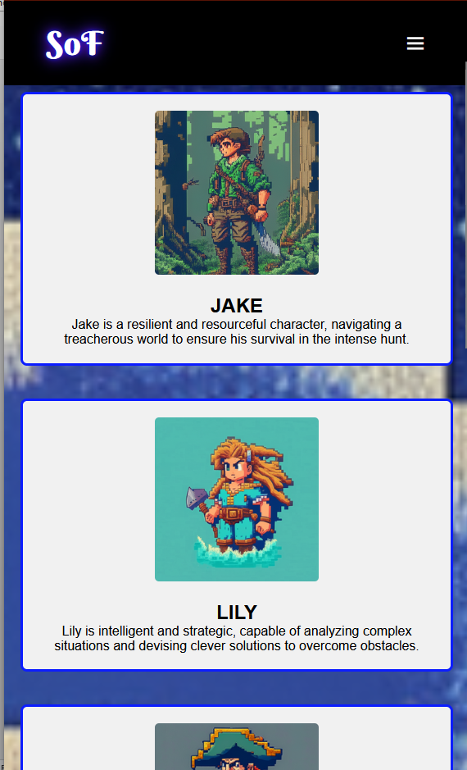

Untuk Halaman Character, saya memasukkan character game. Saya memasukkan deskripsi dan cerita singkat setiap character. Saya menggunakan hover effect dan jika di hover, character akan membesar. Gambar Character saya peroleh dari Ai image generator.

Refernsi:

Link gambar: <https://gencraft.com/> (saya mengambil semua gambar menggunakan Ai)

**4.Halaman Fan Art**

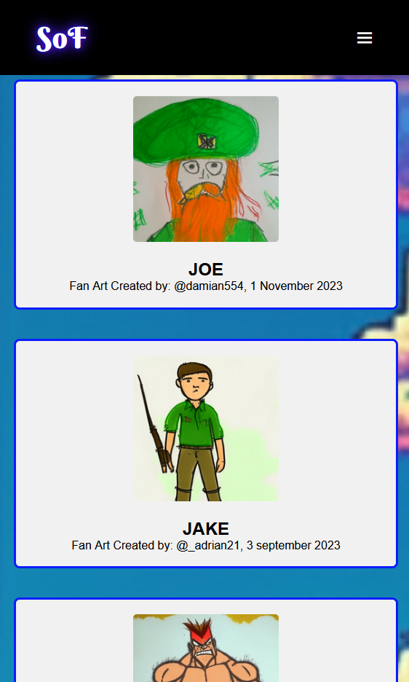

Untuk Halaman Character, saya memasukkan character game. Saya memasukkan nama user dan tanggal gambar telah ter-upload pada setiap fan art. Saya menggunakan hover effect dan jika di hover, Card Fan art akan membesar. Gambar Fanart dan background saya peroleh dari Ai image generator.

Refernsi:

Link gambar: <https://gencraft.com/> (saya mengambil semua gambar menggunakan Ai)

**5.Halaman Account/ register**

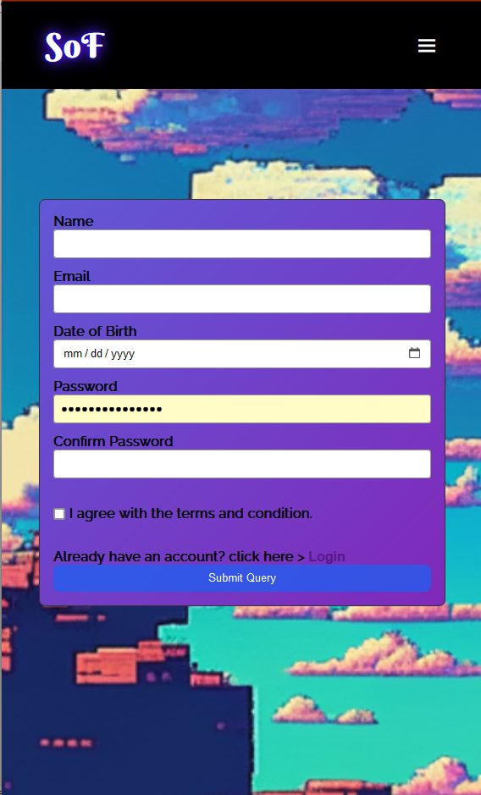

Untuk Halaman register/account, saya meminta memasukkan input untuk user memasukkan Nama, Email, Tanggal lahir, Passsword, konfirmasi password, meminta checklist darin user untuk setujju dengan syarat dan ketentuan, jika sudah mempunnyai akunn maka dapat memencet tombol login, dan yang terakhir untuk submit query. Gambar background sasya peroleh dari Ai image generator

Referennsi:

Link gambar: <https://gencraft.com/> (saya mengambil semua gambar menggunakan Ai)

**Guidelines:**

* + - * 1. Design your website by observing the principles of **human and computer interaction**. Set up your site as **creative** as possible but still strive for **consistency**.
        2. The **website prototype** must be designed using **Figma** and make suretocreate some **features**, such as color and text style, effect, component, variant or interactive component, and navigation.
        3. Consider the **color**, **font**, **size**, and **layout** that you use to design the prototype and website.
        4. All pages mentioned in the requirement should be created **based on your template design**.
        5. Use only **external** **CSS**. Internal or inline CSS will not be marked.
        6. Use **CSS box positioning** to design your web structure**,** do not use table for the layout.
        7. Consider the **language** you use, including spelling and grammar, feel free to choose either Bahasa or English, but you cannot have both at the same time.
        8. Make your website **responsive** so it can deliver in any size, particularly for **desktops**, **tablets,** and **mobile devices**.
        9. Organize your files with subdirectories.
        10. Include references (link from a website, book, etc) that you use in creating the website.